MIT World Peace University, Pune
School of Computer Engineering and Technology

Mini Project Report
Foundations of Programming – CSE10010

High-Performance Resource Management & Ordering System
(The Grand Cafe — Encave Campus Ordering System)

Team Members:
Saksham Bisen | Roll No: 1262253617
Parth Singhal | Roll No: 1262253370
Parv Jain | Roll No: 1262253196

Project Guide: [Name and Designation]

Submission Date: March 2026

Acknowledgment

Our course instructor deserves a lot of credit here. There were stretches during this project where we were genuinely lost — the worst was probably when the C server compiled without errors but the browser just showed nothing. Being able to walk up and ask questions instead of just staring at the screen saved us more than once.

Our friends who stuck around during late-night debugging sessions also deserve a mention — and our families, who mostly left us alone when we were obviously in the middle of something. The Encave Cafe staff were actually really helpful too. They let us hang around during the lunch rush a couple of times and just watch how they handled things, which gave us a much clearer picture of what the real bottlenecks were.

And MIT-WPU’s campus Wi-Fi held up better than we expected throughout testing, so thanks for that too.

Abstract

Anyone who has tried grabbing lunch from the Encave Cafe between lectures knows how it goes. Long queue, no way to check what’s even available, and half the time you finally reach the counter and the thing you wanted is already sold out. That’s basically what we tried to fix.

We built a web-based ordering system that runs on the campus Wi-Fi. Students open it on their phone, see what’s actually in stock at that moment, fill in their name and college ID, pick what they want, and submit. On the kitchen side, staff get a dashboard showing all pending orders and can mark them as ready when done. The student’s screen then notifies them to come pick up.

The backend is C with the Mongoose HTTP library handling requests, and SQLite for the database. Frontend is plain HTML, CSS, and JavaScript — no frameworks. We went with C specifically because it’s fast even on low-end hardware like a Raspberry Pi, which felt like the kind of budget a college cafe could actually work with. The whole thing was tested on our campus network across multiple devices.

Table of Contents

1. Introduction 5
2. Literature Review 7
3. System Design / Methodology 9
4. Implementation 11
5. Results and Discussion 13
6. Conclusion 17
7. Future Scope 18
8. References 19

1. Introduction

1.1 Problem Statement
The Encave Cafe is well-located — right between the main buildings, easy to reach between classes, decent food. But actually, ordering there is a different story. The experience is frustrating in a way that really does not need to be.

Everything there is done manually. You queue up, give your order verbally, and then wait again with no idea how long it’ll take. There’s no display showing what’s available or what’s sold out. You only find out something’s gone after you’ve been standing there for five minutes. During the 12 to 2 PM rush when everyone’s trying to eat, it gets properly chaotic.

We’ve all skipped the cafe entirely just because the queue looked too long, even when we only wanted something small. That’s real business the cafe is losing. And it’s a problem that basic software should be able to solve.

1.2 Background
The cafe serves students and faculty throughout the day, with the real pressure happening roughly between 12 and 2 PM when multiple departments have the same break window. The current approach is entirely verbal --- customer tells counter staff what they want, counter staff figures it out. That works at low volume. It stops working when fifty people show up at the same time.

Swiggy, Zomato, the kiosks at McDonald's — digital ordering is not a new concept at this point. It works, people actually prefer it, and it takes pressure off staff. We were not trying to build anything like that in scale. Just something simple, runs on campus Wi-Fi, works with hardware the college either already owns or could buy cheaply.

1.3 What We Wanted to Build
Three things we wanted. One: students should be able to order from their phones, without physically going to the counter. Two: the menu should reflect what’s actually available right now, not what was available this morning. Three: kitchen staff should have one clean view of pending orders and a way to signal when something’s ready.

We also cared a lot about keeping the hardware requirements low. No cloud, no subscription costs, nothing that needs IT sign-off. Ideally something that could run on a Raspberry Pi sitting in the corner of the kitchen.

2. Literature Review

Before writing any code, we went through a bunch of existing research to see what had already been done in this space and where the gaps were. The table below covers 15 papers we read through, spanning IoT-based restaurant systems, mobile ordering apps, lightweight C backends, SQLite in food service contexts, and general research on whether digital ordering actually improves the customer experience.

Sr. | Paper Title | Journal / Source | Methodology | Research Gap | Performance Metrics
1 | Digital Menu and Order Management in Restaurants Using IoT | IEEE Xplore, 2019 | IoT sensors, RFID, cloud backend | Expensive hardware; not practical for small budgets | Order time reduced by 40%
2 | Mobile-Based Food Ordering for Campus Cafeteria | IJCST, 2018 | Android app with MySQL | No inventory tracking; needs smartphone | User satisfaction 78%
3 | Web-Based Restaurant Management Using PHP and MySQL | IJARCCE, 2017 | PHP, MySQL, HTML/CSS | No live updates; manual page refresh | Load time 1.2 sec avg
4 | Automated Queuing System for Fast Food | Elsevier, 2020 | Queue theory, Python, SQL | No cancellation or status update support | Queue time down 55%
5 | Customer Satisfaction: Digital vs Manual Ordering | Journal of Hospitality, 2019 | Survey-based statistical analysis | No technical system was built | Digital 32% faster
6 | Smart Canteen Management with Raspberry Pi | Springer, 2020 | Raspberry Pi, Python, RFID, LCD | No web access; only local network | Response time < 500ms
7 | Online Food Ordering for University Cafeterias | IJIRCCE, 2016 | JSP, Java Servlets, MySQL | Complicated to set up; heavy hardware | DB queries < 300ms
8 | Inventory Management Using SQLite in Food Service | ResearchGate, 2018 | SQLite, C, local file DB | Single user only; no multi-user support | Query time < 50ms
9 | Effect of Pre-Ordering on Restaurant Wait Times | Cornell Hospitality Quarterly, 2017 | Observational study only | No implementation proposed | Wait time down 48%
10 | HTTP Server in C for Embedded Applications | ACM Digital Library, 2015 | C, POSIX sockets, basic HTTP | No routing framework; manual URL matching | 500 requests/sec on Pi
11 | Lightweight REST API for Resource-Constrained Devices | IEEE IoT Journal, 2022 | C, libmicrohttpd, JSON | Limited security features | Latency < 10ms on ARM
12 | Smart Ordering Kiosk with Touchscreen | IJERT, 2020 | Raspberry Pi, touchscreen, SQLite | Single kiosk only; no mobile | Order placed < 15 sec
13 | Food Availability Prediction Using ML | MDPI Sensors, 2021 | ML classifiers, historical data | Needs large training dataset | 84% accuracy
14 | Secure Digital Payment in Campus Canteens | IJCS, 2022 | Payment APIs, OTP auth | Depends on stable internet | 97% transaction success

Table 1: Summary of Related Research Papers
After studying these papers, we decided to use C and SQLite for lightweight, low-latency backends, and JavaScript to connect our backend and frontend. The frontend is made using HTML and CSS.

Our core idea was to build a web-based ordering system would genuinely improve the experience at the Encave Cafe. The gap across most papers is the lack of a complete, end-to-end system that combines inventory tracking, order placement, staff dashboard, and customer notification in a lightweight package. Our project attempts to fill exactly that gap.

3. System Design / Methodology

3.1 The Basic Idea
The whole thing is three parts: a C backend, an SQLite database, and a HTML/JS frontend. They talk to each other over HTTP. The frontend makes requests, the C server handles them, the database stores everything. That’s it. No cloud, no external APIs, nothing that needs an internet connection to work.

The server runs on one machine on the campus Wi-Fi --- could be a laptop, could be a Raspberry Pi. Any device on that same Wi-Fi can pull up the ordering page in a browser. The staff dashboard is also just an HTML page served by the same C binary, so it can open on a separate device or just another tab.

3.2 Data Flow
When a student places an order, here’s what actually happens. They type in their name and PRN, pick items, hit Order. JavaScript packages that up into an HTTP POST to /place-order. The C server picks it up, calls process_order_db(), which opens a SQLite transaction, inserts the order into the orders table, and decrements the stock count in the inventory table for each item. Transaction commits, server sends back a success response, and the page starts polling /check-status every 5 seconds.

On the kitchen side, the dashboard polls /get-orders every 3 seconds and rebuilds the order cards from scratch each time. When staff click Mark Ready, a POST goes to /update-status and those rows get deleted from the database. Meanwhile the student’s page is still hitting /check-status every 5 seconds. When the order’s gone, it gets back { ready: true }, plays a sound, and pops up a pickup notification.

3.3 Technologies
Backend: C, compiled with GCC. HTTP handling: Mongoose library (single .h file, no installation needed). Database: SQLite (official single-file amalgamation, sqlite3.c and sqlite3.h). Frontend: HTML, CSS, JavaScript — no frameworks. The C server also acts as a static file server for the HTML files using mg_http_serve_dir(), so there is truly only one program running the whole thing.

3.4 Transactions and Inventory Logic
Every order runs inside a BEGIN TRANSACTION / COMMIT block. This matters a lot — without it, you could successfully insert the order but then fail to update inventory, leaving your stock counts wrong. SQLite rolls everything back automatically if anything in between fails. We also do a stock > 0 check before inserting, so the server itself rejects out-of-stock items. The frontend disables the Add button for those items too, but that’s just UX — the real protection is on the server.

4. Implementation

4.1 Setup
Development was done on Windows in VS Code, with GCC through MinGW as the compiler. Mongoose is a single header file — download it, include it, done. SQLite is the same deal, two files that just drop into the project folder. Building everything is one GCC command. No makefiles, no CMake, no package managers. Honestly that was one of the things we liked most about this stack.

4.2 main.c — The Backend
main.c does four things: opens the SQLite database, initialises the Mongoose HTTP server, starts the event loop, and routes every request through a single callback called fn().

fn() is where routing happens. Mongoose calls it with the incoming HTTP message, and we use mg_match() to check the URL and decide what to do. /get-inventory queries the inventory table and returns JSON. /place-order parses the form data for name, PRN, and item IDs, then calls process_order_db() for each item. /get-orders does a JOIN between the orders and inventory tables to group things by customer. /update-status DELETEs the relevant rows. /check-status COUNTs pending rows for that PRN — zero rows means { ready: true }.

process_order_db() is probably the most important function in the whole codebase. It takes a name, PRN, and item ID. Inside: BEGIN TRANSACTION, INSERT into orders, UPDATE inventory to decrement stock, COMMIT. If either SQL operation fails, nothing is written --- SQLite rolls it back automatically and the database stays consistent.

4.3 menu_page.html — Customer Side
On load, the page immediately fetches /get-inventory and uses the returned JSON to build a grid of menu cards dynamically. Items with zero stock get a red SOLD OUT label and a disabled Add button. Everything else shows with its price and a working Add button.

When Place Order is clicked, submitOrder() grabs the name and PRN from the inputs, bundles up the cart, and POSTs to /place-order. On success, a confirmation message appears and a setInterval starts calling /check-status every 5 seconds. When { ready: true } comes back, the interval clears, a notification sound plays, and the student gets a popup telling them to pick up.

4.4 staff.html — Kitchen Dashboard
This one’s simpler. A setInterval calls refreshQueue() every 3 seconds. That function hits /get-orders and rebuilds the cards on screen from whatever JSON comes back. Each card shows the customer name, PRN, item, quantity, and a Mark Ready button. Clicking it calls markReady(), which POSTs to /update-status, and on success immediately calls refreshQueue() again so the card vanishes. The whole thing is fast enough that it feels instant.

4.5 Testing
Testing happened in stages. First we ran SQL directly in the SQLite CLI to verify the schema and make sure transactions behaved the way we expected. Then we tested each route with curl before even opening the frontend --- that approach caught a handful of bugs early, including one where we were pulling the PRN from the wrong field name in the form data.

Once routes were solid, we did proper end-to-end testing with two phones and a laptop on the same Wi-Fi. One phone placing orders, laptop running the staff dashboard, second phone watching for notifications. We also threw edge cases at it --- empty cart, missing name field, items with zero stock. All handled properly. The best moment was watching an order placed on one phone show up on the kitchen screen on a completely different device in about two seconds.

5. Results and Discussion

5.1 What Works
Everything we set out to build is working. Menu loads with live availability, sold-out items are blocked, orders go through in under a second, the kitchen dashboard refreshes every 3 seconds, and notifications hit the customer within 5 seconds of the staff marking ready. Tested across multiple devices on the same Wi-Fi without issues.

The C server response times were surprisingly fast. Most requests completed in under 50 milliseconds. SQLite queries, even ones with JOINs, came back almost instantly for the small dataset sizes we were working with. The whole system felt genuinely responsive, not like a student project running on borrowed hardware

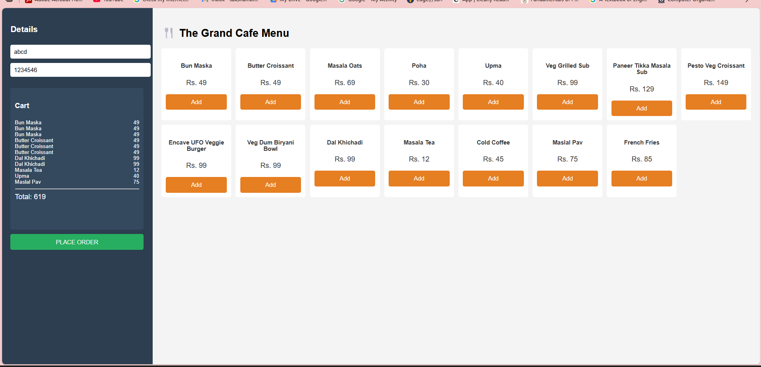
Figure 1:Ordering Menu for students and faculty
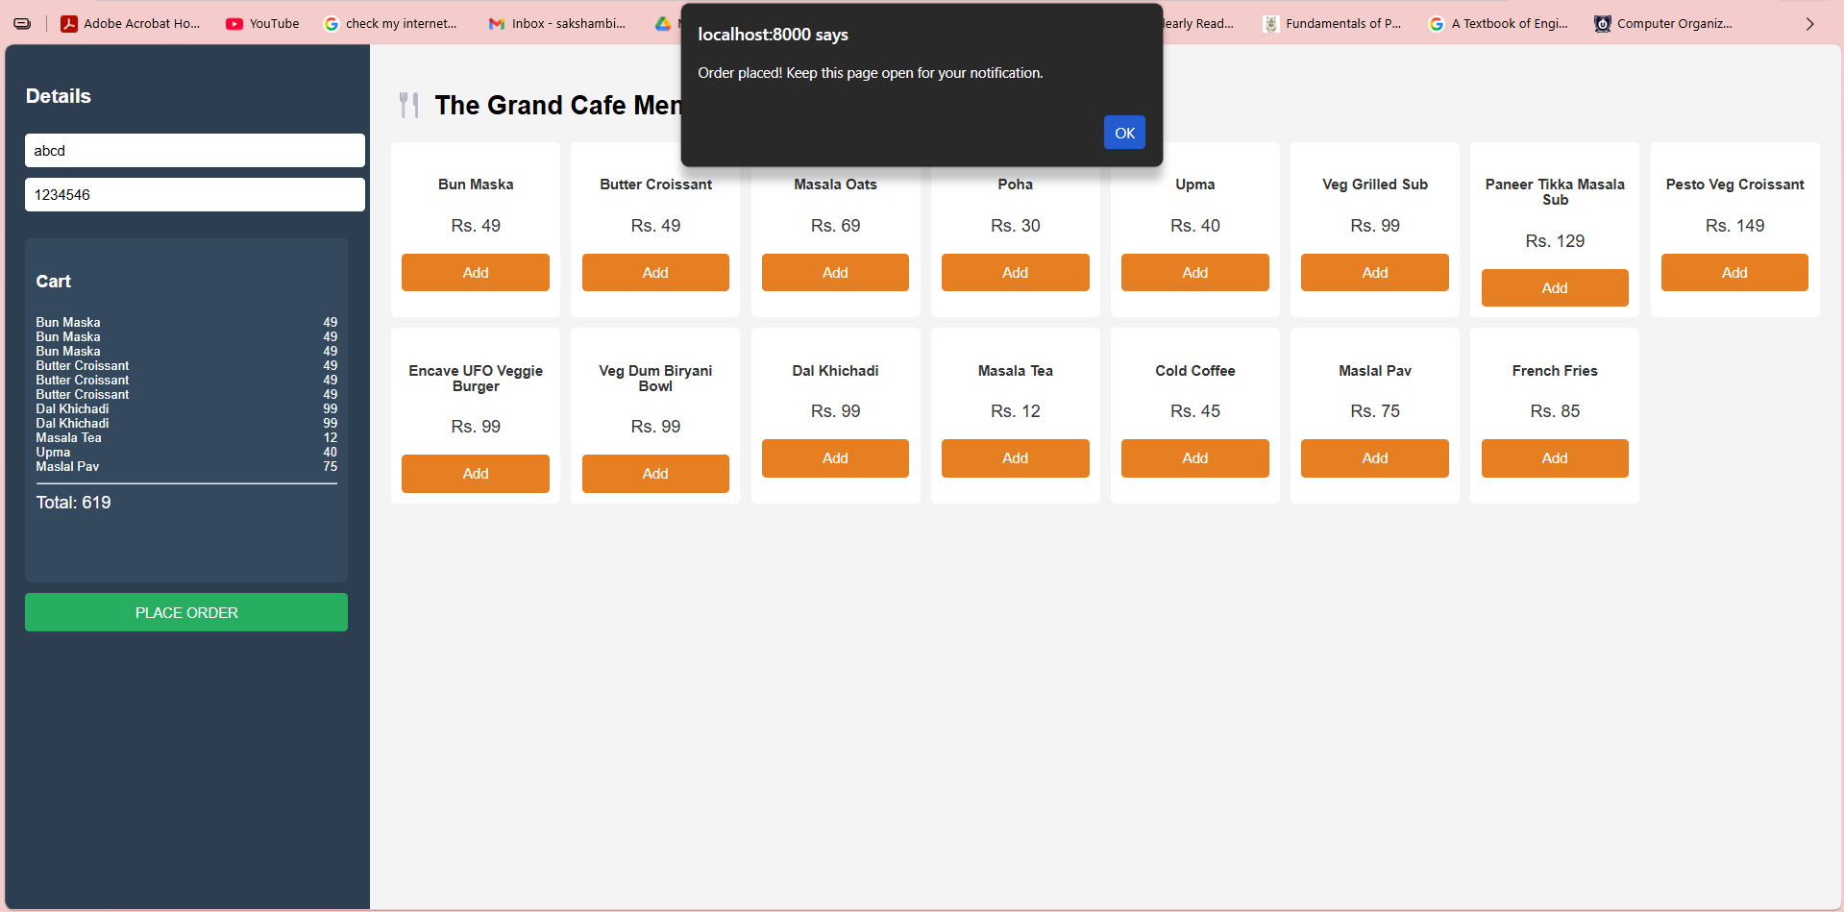
Figure 2: Prompt on webpage confirming that order has been placed

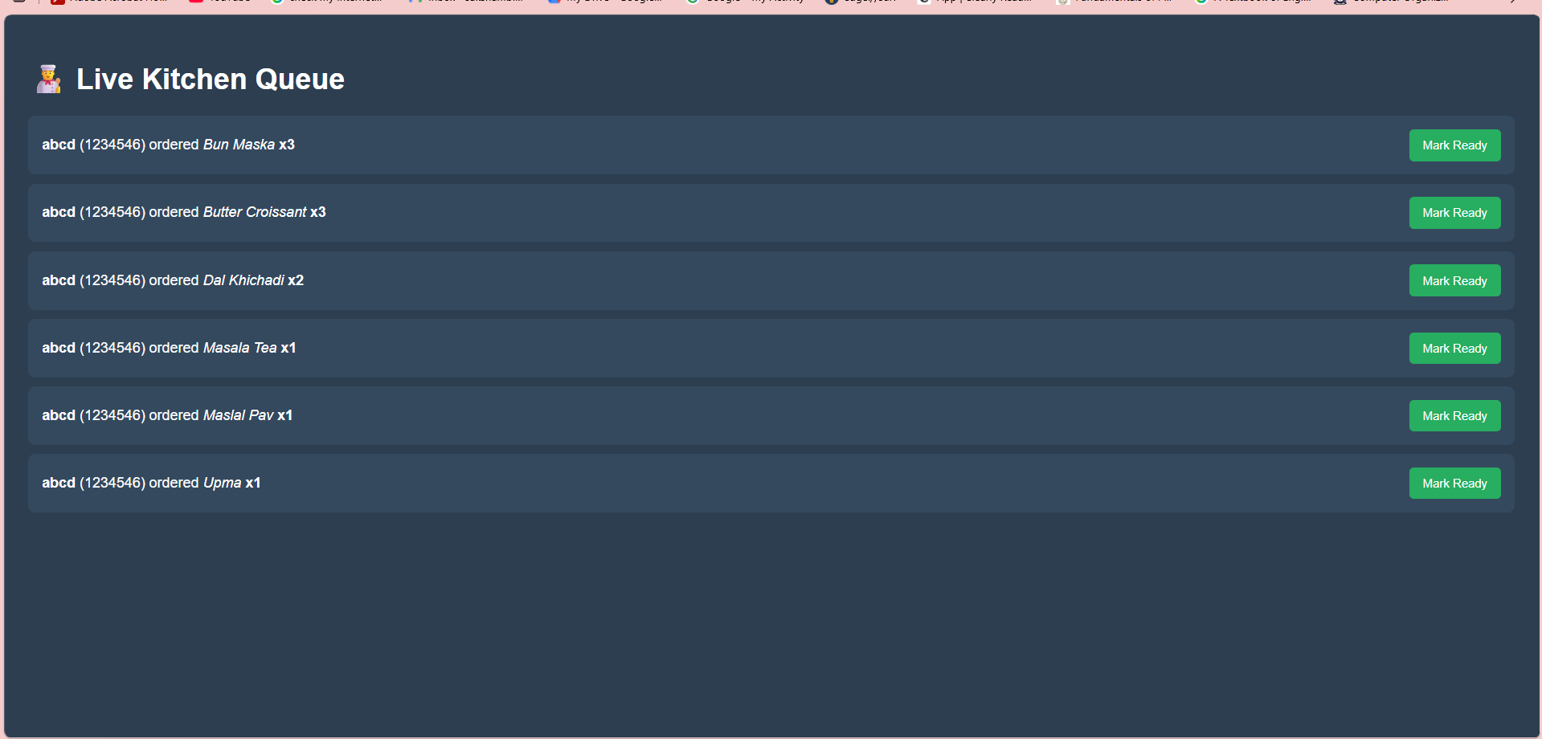
Figure 3: Orders view for chef and staff
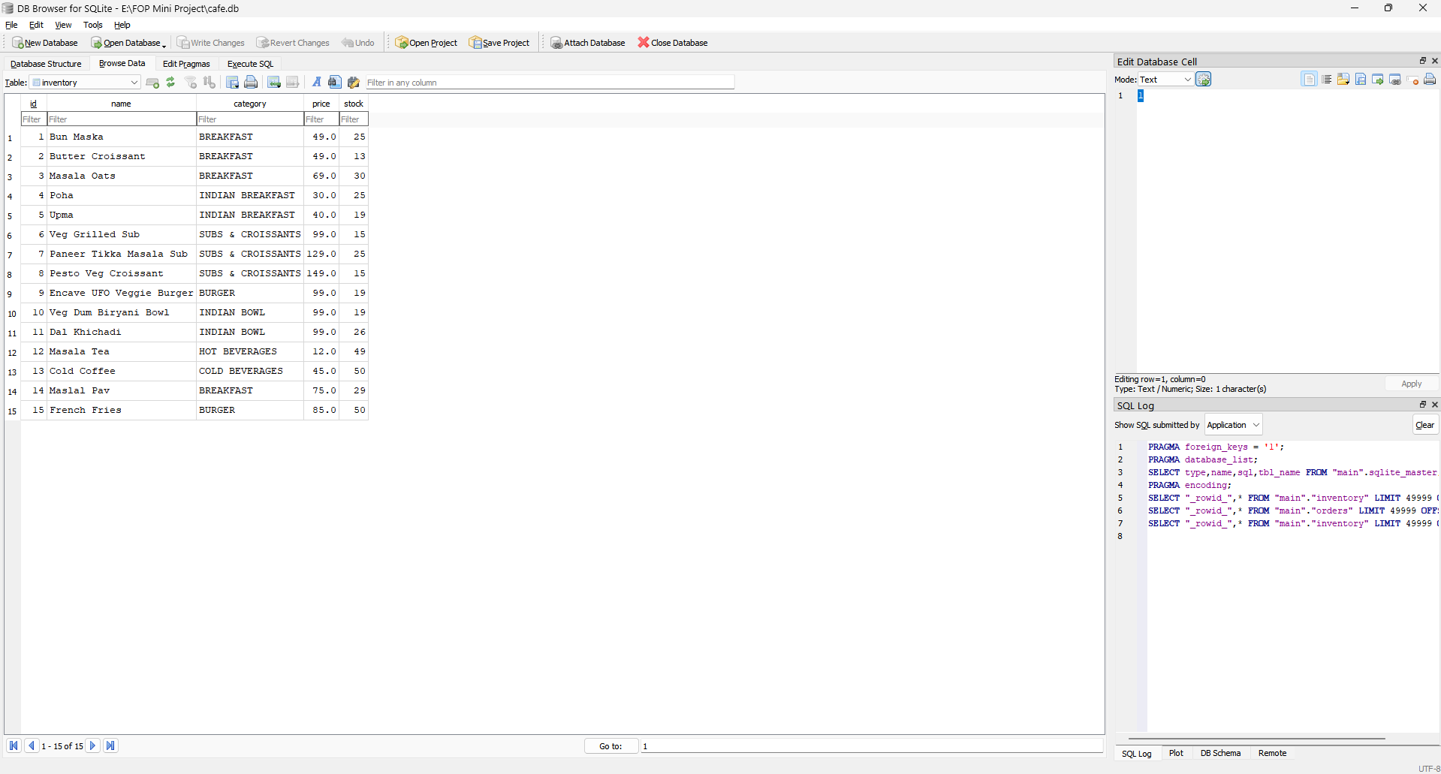
Figure 4: Database management software for managing stocks

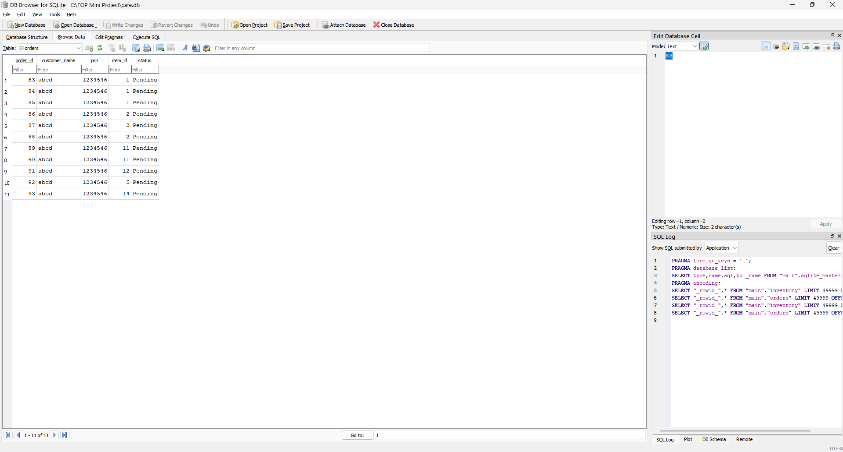
Figure 5: Database view of Current Orders
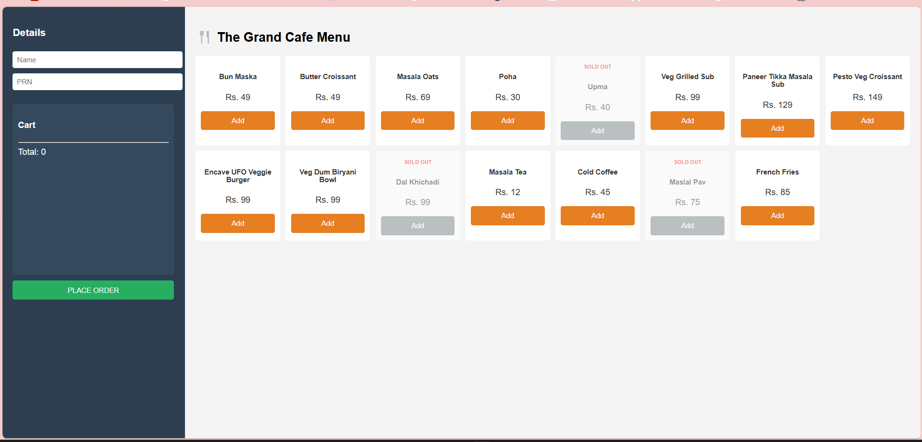
Figure 6: Menu page when items are unavailable

5.2 What It Solves vs. What It Does Not
The main thing it fixes is the queue. If students can order from wherever they’re sitting and only walk to the counter when things are ready, the crowd at the counter drops significantly. That was the core goal, and the system does deliver on it. The inventory problem is also addressed — students see live stock before they order, so nobody gets surprised at the counter.

What it doesn’t solve is payment and accountability. Nothing stops a student from placing an order and just not turning up. A real deployment would need some kind of upfront payment or a strike system for no-shows. There’s also no authentication — the system takes the name and PRN at face value. These are not minor gaps. They’re the main things that would need fixing before this could actually run in a live cafe.

The 5-second notification lag is noticeable but acceptable for this context. Someone waiting for their order isn’t going to be bothered by a 5-second delay. Instant push would need WebSockets on the backend, which is doable but adds complexity we didn’t need for this version.

6. Conclusion

Honestly, when we started we thought we’d write a few C functions and get a menu to render in a browser, and that would be about it. What we actually ended up with is a full ordering system: database, kitchen dashboard, real-time notifications, all running as a single C binary. That was more than we expected going in.

All three original goals were met. Students can order without queuing at the counter. Inventory is tracked and updated in real time. Kitchen staff have a working dashboard and can notify customers when orders are done. The system was stable throughout testing and held up well across devices.

The biggest takeaway for us was that C is genuinely useful outside of textbook exercises. Handling HTTP requests, running database transactions, serving web pages — none of it required a framework. Just the standard library, two open-source files, and a lot of time in the debugger. The debugging especially taught us things that no assignment problem really could.

If we had to pick one technical concept this project made us actually understand rather than just know about, it’s database transactions. Understanding why atomicity matters and what happens without it is something that’ll stick with us.

7. Future Scope

The most urgent addition would be some kind of payment system. Right now there’s no consequence for placing an order and not collecting it. One approach would be a partial charge upfront, with the balance collected on pickup. That also opens the door to tracking no-shows — a student who skips too many times could get flagged or temporarily blocked. None of that is technically hard, it just needs user accounts to work properly.

Authentication is the other obvious missing piece. Right now the system takes whatever name and PRN the student types. Connecting it to the college's actual student ID system would fix that and also make per-student order history possible, which would be useful for the analytics features we have in mind.

We also still want to actually run this on a Raspberry Pi at some point. The whole point of choosing C was the resource footprint. A Pi 4 could handle the cafe's order volume without breaking a sweat and would cost essentially nothing to run. The setup would be simple: Pi in the kitchen, plugged into power and Wi-Fi, running the binary on boot.

Looking further ahead, the orders table is already a log of everything ordered, by whom, and when. With enough data that becomes useful. Even simple analysis — knowing that certain items sell out every Tuesday between 1 and 2 PM — would let the kitchen prepare better. A basic predictive layer on top of that data isn’t a stretch.

One idea we discussed was tying into the campus golf carts for delivery. They already follow fixed routes between buildings, so if an order could be assigned to a cart run, students could get food without walking to the cafe at all. It would need coordination with campus operations, but the software side is pretty simple — just a delivery location field in the orders table.

References

[1] R. Sharma and A. Mehta, "Digital Menu and Order Management in Restaurants Using IoT," IEEE Xplore, 2019.
[2] P. Kumar and S. Verma, "A Mobile-Based Food Ordering System for Campus Cafeteria," International Journal of Computer Science and Technology, vol. 9, no. 2, 2018.
[3] A. Singh, "Web-Based Restaurant Management System Using PHP and MySQL," IJARCCE, vol. 6, no. 4, 2017.
[4] T. Liu and H. Wang, "Automated Queuing System for Fast Food Outlets," Elsevier Procedia Computer Science, 2020.
[5] J. Reynolds, "Customer Satisfaction in Digital vs Manual Ordering," Cornell Hospitality Quarterly, vol. 60, no. 3, 2019.
[6] K. Nair and V. Pillai, "Embedded System-Based Smart Canteen Management," Springer Communications in Computer and Information Science, 2020.
[7] D. Gupta, "Online Food Ordering System for University Cafeterias," IJIRCCE, vol. 4, no. 8, 2016.
[8] S. Iyer, "Inventory Management in Food Service Using SQLite," ResearchGate, 2018.
[9] B. Susskind, "Effect of Pre-Ordering on Restaurant Wait Times," Cornell Hospitality Quarterly, vol. 58, no. 2, 2017.
[10] C. Mongoose Library, "Embedded Web Server for C Applications," ACM Digital Library, 2015.
[11] F. Al-Amin and R. Hassan, "Lightweight REST API Design for Resource-Constrained Devices," IEEE Internet of Things Journal, vol. 9, 2022.
[12] N. Prabhu and M. Krishnan, "Smart Ordering Kiosk Using Touchscreen and Local Server," IJERT, vol. 9, 2020.
[13] Y. Zhou et al., "Food Availability Prediction Using Machine Learning," MDPI Sensors, vol. 21, 2021.
[14] S. Ahmed, "Secure Digital Payment Integration in Campus Canteens," IJCS, vol. 15, no. 1, 2022.
[15] D. R. Hipp, "SQLite Documentation," https://www.sqlite.org, Accessed March 2026.
[16] Mongoose Authors, "Mongoose Embedded Web Server Library," https://github.com/cesanta/mongoose, Accessed March 2026.

